Lord What Are You Doing With Us in This Hour?
June 29, 2016
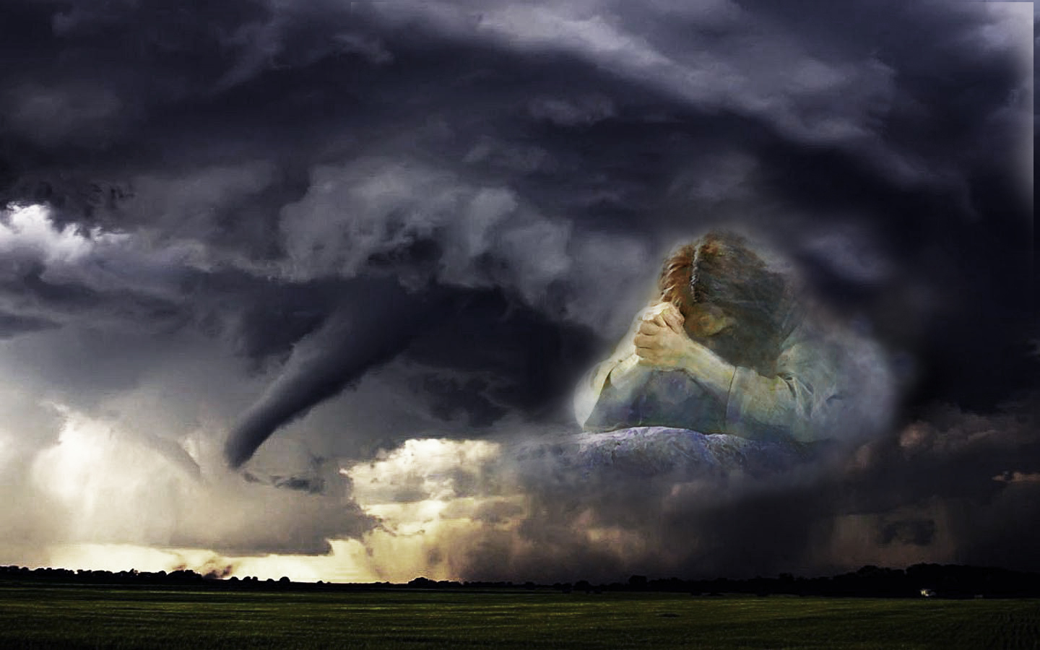
Our waiting is not in vain, dear Heartdwellers. There is a rich windfall of graces being dispensed to us in this hour; graces that will impact our eternity and the eternity of others. So, be encouraged.

Today, as I came into worship, (and actually, that was yesterday) I felt strongly the need to be present to the Lord as His Bride. I was soon feeling and seeing myself in His arms, moving to the music and really getting ministry from the songs as I sang them to Him in my heart. I knew He was singing some of them back to me as well, and all my fears and false guilts just melted away.

I began, “Thank you, Lord, for the extra strength and wonderful dance time.”

Jesus answered me, “I was hoping you’d like it. I sing to you from My heart, you know. I pick those songs because they truly mean something to Me. They convey how I feel about you.”

Lord, this feels very much like puppy love.

"That’s right." He said. "Innocent and pure puppy love. Isn't it wonderful?"

Just catching a glimpse of Your face feels wonderful…Resting over Your heart is wonderful... Knowing how much You care feels wonderful... Never have I been loved like this before, and only Ezekiel comes ‘close.’ But He is but a creation and Your love is the love of the Creator.

"Yes, and I created him for you. Would that all could find the love of their dreams, but most do not know how to wait. Waiting is not easy. Waiting implies solid hope; hope is in direct proportion to faith, that what you are hoping for will become an eventuality. That is the realm you are all operating in. And the stronger your faith, the more productive and peaceful you will be.

"That is why Satan tries so hard to undermine your faith; so much depends upon it. When a soul becomes impatient, they choose many wrong turns and I must go ahead of them to steer them back on the right track. As your faith increases, so does your hope increase, until you are so full you are spilling over onto others. You are radiant with hope, because you know Who you have put your trust in. This is the point at which you can touch others in the deepest way.

"As My Bride is waiting in faith, she is hoping and increasing in glory, which will flow out on to others. Without waiting, there can be no hope. And without faith, waiting is fruitless. What I am saying is that you are all growing in faith, hope and trust. Each day you are becoming stronger and stronger. This impacts many areas of your lives, more than you realize. It is like weight lifting. Building up spiritual muscle also has its affect on speed, agility, endurance and strength.

"Waiting, in a similar way, affects your whole life and the way you do things. You are exercising self-control based on your faith in Me - you are waiting on Me.

"Oh, it does so much, Clare, it cannot be calculated.

"This precious group of souls who have rallied around you, to hear from Me, are shining lights in the world. Their luster is not flashy or of this world; rather they appear dull and drab and of no consequence. And that is the safest possible place to be.

"Have I not said, 'I have chosen the foolish of this world to confound the wise?'"

Lord, I just got that rhema.

"Yes, indeed, it is good for you to be reminded of that. Missing a front tooth is a good exercise in humility."

Oh boy...

"Nevertheless, I know how happy you will be to get rid of the ‘goofy’ smile."

Very happy, Lord. Thank you.

"Restful waiting also releases your time; you are not filled with anxiety, trying always to figure things out. Rather, you trust that I am in control and you will know what you need to know... when you need to know it. Do you realize how much glory that brings Me? When you say to others, 'I don’t have the answer, but Jesus does. And when He is ready He will tell me.' What a holy example to live by.

"If your life is going well, and you can trust Jesus - then by example you are saying, 'You can trust Jesus, too.' These are ways, My Brides, that you bear witness to Me. Because I am so real to you, almighty and powerful and worthy of entrusting your very lives to Me. By that example, you declare that I am Lord. People watch your actions; they are far more interested in what you do and how you do it than what you say.

"You are the light of the world and your very presence in a room changes the atmosphere. Your peaceful and calm demeanor radiates, just as an angry demeanor changes how people feel. When you live your life resting in Me, you declare that I am alive and well, living in you. When you are agitated, fearful and impatient - you declare your insecurity and mistrust of Me.

"In short, by your faith-filled watching, you are causing others to turn their glance to Me, to trust Me and follow My lead. You see, this is part of what I am accomplishing right now in you. Your very security, resting in Me, removes you from the machinations of the world and all the error that goes forth from it."

And at this point, I had to go to bed, because it was all that I could really concentrate and receive from Him. So, the next morning, I woke up.

And I said, “Lord, You have filled me so sweetly with Yourself, I’m floating! Jesus, You are so good to me."

And that was the effect of the worship that we had that morning.

He answered me, "How could I be anything other than that? I love you so much, Clare. You may not have as much as other souls so very rich in virtue, talent and intellect, but what you do have you’ve given to Me. And now you have My riches, My talents and intellect. What more could you possibly want?"

Of course, I always want more, so I said, "Your waiting arms, that transport me right into Your heart of hearts. The place of my delight, Lord".

And today in worship, I saw that as we danced, I was wearing my wedding dress and He was wearing a black tuxedo, tastefully trimmed with black satin on the lapels. Even before we danced and I went into worship, I could hear His thoughts flooding my mind, which was still in the process of waking up.

The Lord cut in, “And those thoughts are probably one of the most important messages I have for My people in this hour.

"Dear Ones, you are the Chosen Generation. You have been sent to the Earth for such a time as this. Yours is to prepare those who will survive into the Tribulation. Your legacy is holiness - without legalisms. You are, by your examples, retrieving souls from the pits of disillusionment and raising them up into a true relationship with Me, free from the oppressive trappings of Religion.

"Oppression begins where anointing leaves off. All that is done without My Holy Spirit is of man and the flesh. Rules and structure are only useful when they do not quench My Spirit, but rather support Him in His workings within a body of believers.

"The world is so full of victims of Religion and many of them were highly anointed and suppressed. They became disillusioned and isolated, lacking the sweet exchange of fellowship. Beguiled by spirits of false guilt, they toss to and fro, blaming themselves, blaming churches, back and forth as the enemy torments them.

"You have been chosen to lead them down the pure path of Love, that still conforms to the Scriptures. You have been called to raise up the end times warriors from their pits of despair and isolation and bring them this good news: 'Jesus is not a Religion; He is all about relationship, an intimate relationship.'

"You are preparing those who must survive the Tribulation; this is your contribution.

"I know you have been focused on the Rapture, and never should you lose your bearings in this regard. But you have something more to do for Me while you are waiting; a contribution to make and leave behind. You were chosen for this hour, to rescue souls out of their pits of disillusionment and into an army fit for battle - one of the last battles on Earth - simply by imparting this Truth to them."
And that truth is that Jesus is not a religion; He's all about relationship.

The Lord continued, "Once this is truly grasped, all the rest will follow, because they are in right relationship with Me. In this hour you have a very special purpose: it is yours to rouse and encourage them.

"I have been awakening you to the other side of your calling, to leave a legacy of love and faithfulness to My Spirit and the Scriptures. So that, reflecting on your lives, they may rise up in Me and fight the remaining battles with all the RIGHT tools. Legalism chained and banished, fidelity to the Heart of the Law and moving with My Spirit in complete freedom of expression, as a Body. Not an isolated soul here and there.

"In your courageous efforts to stay in unity on this Channel, you have opened the door for others to learn the meaning of the words, 'Love one another as I have loved you.' You have shown that on YouTube there can be a family of righteousness and brotherly love where backbiting, division, one-upmanship and undercutting one another is exposed as evil and not allowed. And as a result, even those who come here with malcontent are encouraged with kind words and prayer to draw closer to Me, lay down their rancor and embrace a different way full of peace and good fruits. A way where I welcome them into My arms…no matter how foul their past may be.

"You have a job to do, you who dwell in My Heart. I gave you My all. I am asking you: leave behind your all for others. You are the light of the world and you will shine most brightly just before I take you to Myself. You are leaving an imprint on those who behold you, an imprint of Who I truly am to them. And just like the shroud I left behind, the imprint left on you from dwelling in My Heart will leave a lasting impression.

"You will also observe that each time we get close to the Rapture and you vigorously apply yourselves to prayer, there is a major breakthrough. These breakthroughs are no accident. They open the doors of Hope for your unsaved loved ones.

"This last rally, as things came close - there were multiple international breakthroughs, with sleeping eyes opening to the evils of a Satanic One World government. Which has been billed as a step forward for humanity, but is being recognized now for what it really is: another opportunity for a dictator, not just over hundreds of thousands - but over millions. A world dictator that will crush every right I handed over to you with free will.

"Because of all the prayers and sacrifices, that paper mask of goodness is starting to wear thin and horns are becoming visible to even those who do not know the Scriptures. Yes, it is true. Revelation will be fulfilled. But I am looking at the millions of souls who will inherit the light shining out from you and others who have embraced the Heart of the Law and will draw all men to Me in brotherly love.

"So, understand. Your very purpose right now is not just to 'make it' in the Rapture. No, that is the consequence of you living for Me. You have a sacred trust to leave the right impression behind. By your waiting in absolute faith. You are growing in glory and holiness, being transformed from your lowly earthly estate to one fit for Heaven and moving far beyond what you have been in the past. You are outgrowing your earthly caterpillar form - and being transformed with wings for flight.
"You are a chosen generation. An intercessory Body that turns the tides of nations by your focused prayer when we come close to that final hour. Though the Rapture is averted, you bring many major breakthroughs, obtaining time for those who had no more time.

"You are a light to the nations, a living image of unconditional love, without the constraints of controlling religious spirits. You are the generation chosen to leave behind what you have received, while dwelling in My heart. This will impact the way the Last Days Army rises up out of the dirt of past failures and disappointments.

"Waiting is not easy, but is transforming from glory to glory, as you exercise faith, hope and trust in Me, and shining brightly in a world with no hope. All of Heaven is looking on these last days. You carry My words as you live them before man.”

As the Lord was imparting these thoughts to me, I had a consistent image of a huge tsunami of Grace pressing in from the dawn of Earth’s time. Beginning with Adam and Eve, Abraham through Moses, the prophets and kings, the early church, the great Christians of the dark ages, the Desert Fathers, the reformation and all the great evangelists and moves of God to our present day. It came from the dawn and progressed through the day as it moved across this vast ocean of time, and now is making landfall amidst menacing slate-blue storm clouds. It is cresting as the sun is setting, and just beyond landfall is the total darkness of the Tribulation.

When this wave hit a certain point, at its height, I saw that it represented souls living in the sum of all the graces the Lord had shed so far on Earth. All the movements of God were cresting and bringing a tsunami of Holiness to landfall in brilliant golden light. And as it peaked in height, the luminous crest was taken up to Heaven - but not before it left an imprint on those who beheld it from the Earth below.

It was as if an image of Jesus was impressed on this golden wave of souls, who were lifted up and Raptured. And as it ascended, a holy mist descended upon the inhabitants of Earth. And this mist was bright and nourishing, falling upon those left to face the Tribulation. And they received this mist into their beings, where it appeared as a light, and they were nourished by it.

We are riding the crest of that wave, Heartdwellers. We are luminous from all we have inherited from past generations and all God has done in us. We are leaving behind a legacy of Love. We are not just waiting to be taken up. We are enriching those on Earth, by bearing witness of Who Jesus is in our lives, and what He has done for us. From glory to glory. And this glory is what we will leave behind, imprinted on the hearts of all.

So, we are not waiting in idleness. Our earnest prayers are changing nations; our examples are liberating those oppressed by religious bondage. As a family, we are living an example of love...on YouTube nonetheless! Our trustful rest and waiting on the Lord are declaring He is Real and worthy of our trust - even when He is delayed.

And lastly we are leaving an imprint of Who Jesus truly is to each of us.

So, heads up, Heartdwellers. We are here right now for a very specific purpose. Let us not grow weary in well doing, but realize we have been appointed for these times - and the cross of delays is working in us, and in others, the Glory of the Lord. Amen.

